So, I wanted to recap some of the things you wrote to get organized for this model.

- Minimal resource usage
- market clearing
- demand for different goods
- prices
  - Minimal resource usage
    - cores
    - memory
  - Market clearing Algorithm
  - Market prices and quantities influenced by…
    - demand curve budgets
    - Supply curve scarcity
    - countervailing market power
    - behavioral economics
  - Currency
    - What currency should we use?
    - What is the value of this currency?
  - Good/Service Quality
    - Objective Quality
      - craftsmanship
      - lifespan under average/standard wear&tear
- Regulations
  - Price Caps
  - Tolls / Tariffs
  - Regular Taxes
- Crime
  - Theft
  - Tax Evasion
- Environmental
  - Droughts
  - High Productions
- Societal
  - Population
  - Demand due to culture
  - Social Trust
- Religious Factors
  - Kosher/Halal
  - Diet
  - Sacrifices
  - Spirits
  - Spiritual items, like prayer beads, necklace with cross.
- Math Concerns
  - Quick Convergence
- Debt Markets
  - IOU’s
  - Trust
  - Pre-orders?
  - Fractional Reserve Banking

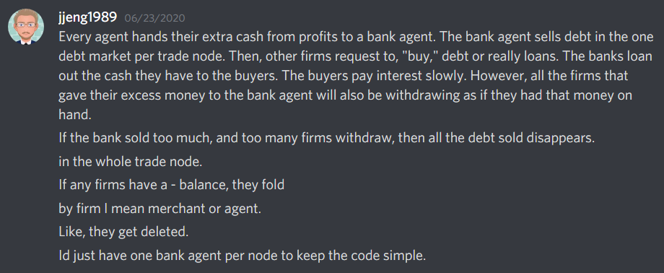
We talked about Using the market clearing algorithm where the demander’s willingness to pay chooses the cutoff for who gets the supplies in a shortage, which is how supply and demand curves work anyway.
Methods We Talked About

General

1. Original agent based model.
2. My excel model
3. Dixit-Stiglitz-Krugman
4. Weighted Average Model

Debt
1. Debt as trust?
2. bank firms compete with interest rates for firm and character savings and loan it out. Insolvency causes local market collapse.
3.

JJeng1989 Model – with city builder
The city is basically a tree structure where each leaf is a building.
Each building's aoe is determined by how many levels up the hierarchy in area it can serve.
Only characters in houses that have access to a certain good/service count in the quantity demanded.
Characters with no access just skip over that good they have no access to when they loop over their purchases.

Added considerations, like how social trust will be a necessary component for modeling money as debt because if people have no social trust, then no one will loan to anyone.

We added religious factors as exogenous to the economy. We added the sub factors to that too.

We talked about how the customer base for Sote in the near run is likely to be intellectual players. So, we will need to add a somewhat smart model into the system.

